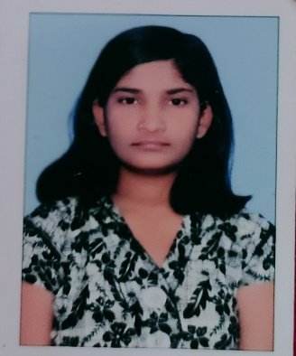 CURRICULUM VITAE

NAME : SMITISHREE GOUDA

ADDRESS : QRT-56/10 SASTRI MARG RAMBHA ,

DIST. GANJAM ODISHA

STATE : ODISHA

PINCODE : 761028

MOBILE : 8917284911 / 7656990060

EMAIL-ID : [smitishreegouda@GMAIL.COM](mailto:smitishreegouda@GMAIL.COM)

LINKED ID : <https://www.linkedin.com/in/smitishree-gouda-698789214>

CAREER OBJECTIVE :

To secure a challenging position in a reputable organization to expand my learning, knowledge and skills.

TECHNICAL SUMMARY :

* **SQL :**
  + - * GOOD UNDERSTANDING ON DBMS AND RDBMS , FUNCTIONS AND OPERATION
      * EXCELLENT KNOWLEDGE ON NORMALIZATION AND CONSTRAINTS.
      * SOLID UNDERSTANDING IN THE CONCEPTS OF SUB QUERIES AND SQL JOINS.
      * PROFICIENT KNOWLEDGE ON COMMANDS LIKE DCL, DML,DCL,TCL.

ACHIEVEMENTS :

* Participate In 21st National Children Science Congress. K V S Guwahati Region(Regional Level).

Theme : Energy :explore , harness and conserve.

Held at k v khanapara , guwahati assam on 4th and 5th oct 2013.

* Has Been Volunteered (Arts) In The Annual Day Which Was Organized At School Level.
* <https://nptel.ac.in/noc/E_Certificate/NPTEL22CS51S43210117NPTEL2201086699>
* <https://nptel.ac.in/noc/E_Certificate/NPTEL22CS31S1320010102199530>
* <https://nptel.ac.in/noc/E_Certificate/NPTEL22CS08S2320021102199530>
* Participate on college seminar : Topic :big data to avoid flight delays

EDUCATION QUALIFICATION ;

* KENDRIYA VIDALAYA TENGA VALLEY ( TENGA , ARUNACHAL PRADESH)

10th 2015

CBSE BOARD

* KENDRIYA VIDALAYA NO.2 ARMY JODHPUR ( JODHPUR , RAJASTHAN)

12TH 2017

CBSE BOARD

SPECIFICATION : SCIENCE WITH BIOLOGY.

* GAYATRI INSTITUTE OF SCIENCE AND TECHNOLOGY , BERHAMPUR (BERHAMPUR , ODISHA)

BACHELOR OF COMPUTER APPLICATION , 2017

BERHAMPUR UNIVERSITY , BERHAMPUR ODISHA

SPECIFICATION : COMPUTER APPLICATION

* ROLAND INSTITUTE OF TECHNOLOGY , BERHAMPUR ( BERHAMPUR , ODISHA)

MASTERS OF COMPUTER APPLICATION , 2022

BIJU PATNAIK UNIVERSITY OF TECHNOLOGY , ROURKELA ODISHA.

SPECIFICATION : COMPUTER PROGARMING AND APPLICATION.

HOBBIES :

* Surf the web.
* Painting.
* Photography.
* Blogging.

STRENGTH :

* Dedicated.
* Positive thinking.
* Punctual.
* Good listener.
* Adaptability to change environment.

PERSONAL PROFILE :

* NAME : Smitishree Gouda
* FATHER NAME : Ranjit Singh Gouda
* DATE OF BIRTH : 25TH JULY 1999
* NATIONALITY : Indian
* RELIGION : Hindu
* GENDER : Female
* MARTIAL STATUS : Single
* LANGUAGES KNOWN : English , Hindi , Odia.

DECLARATION :

I Hereby Declare That All The Details Given Above Are True To My Knowledge And Belief.